

**Lab 2: UART IDLP**

**CECS 347**

**Kenny Khut, Kuldeep Gohil**

**October 9, 2019**

**Lab Description:**

The purpose of this lab is to use UART to control the brightness and color of the LED on the Launchpad board. The lab uses the two times from the previous lab to control the brightness of the LED through a pulse. Using UART, we send a signal to the launchpad and the board controls the color and brightness of the LED based on the signal it receives. Brightness is controlled by inputting a number between 0-5, and color is controlled by inputting r,g,b for red,green, or blue.

**Schematic:**

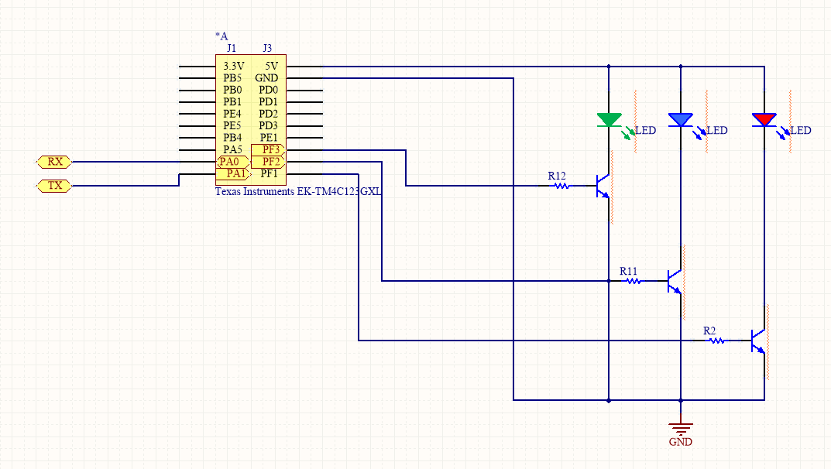

**C source code:**

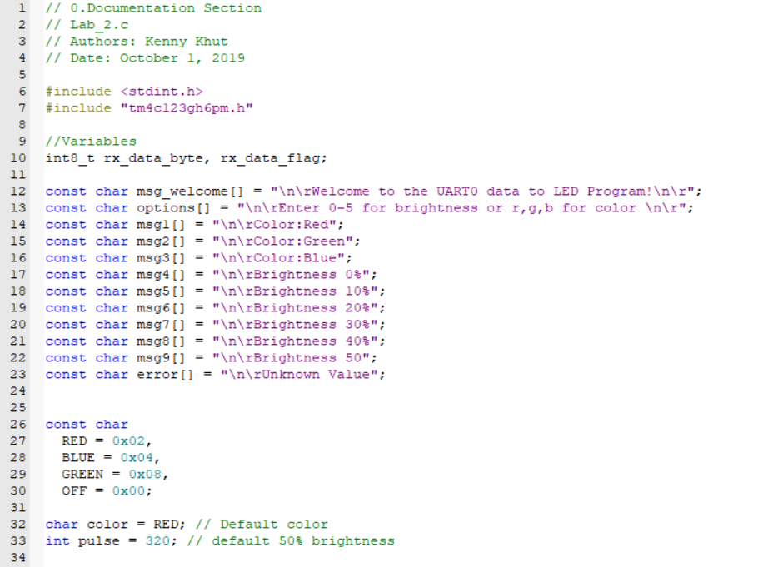

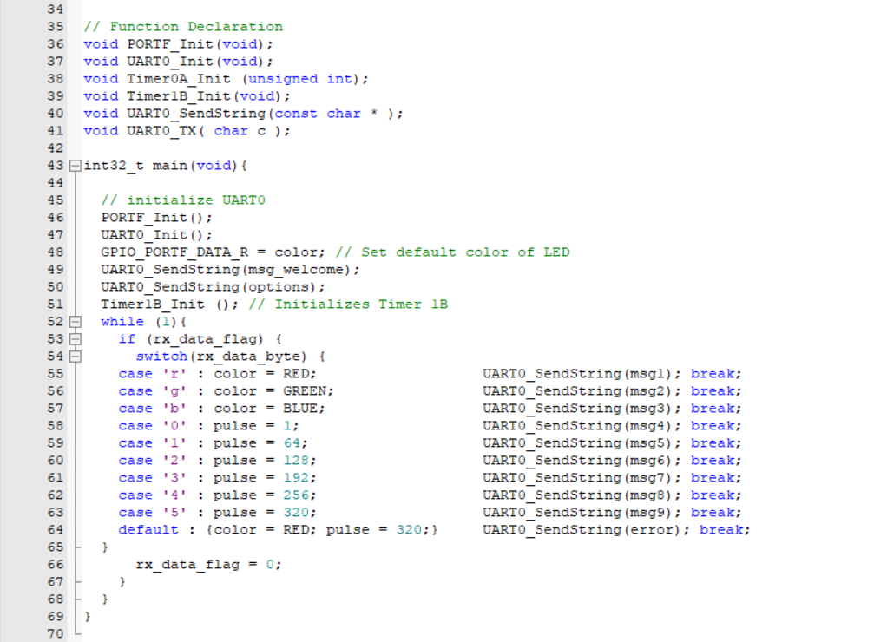

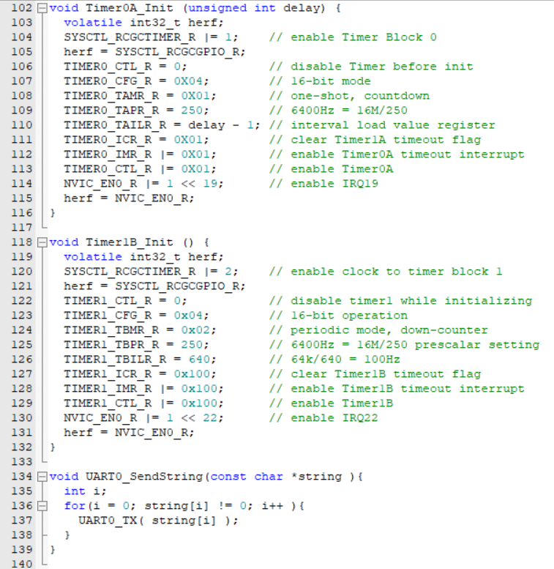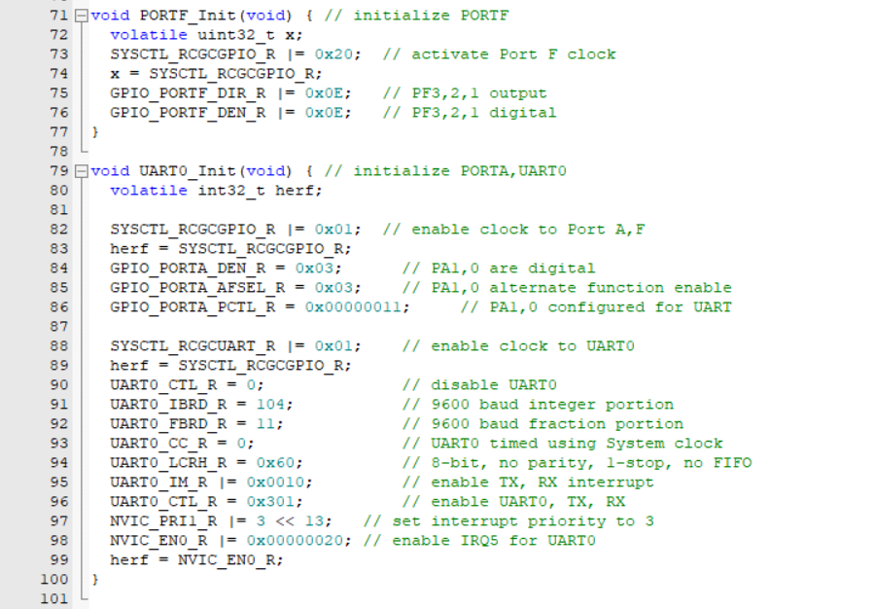

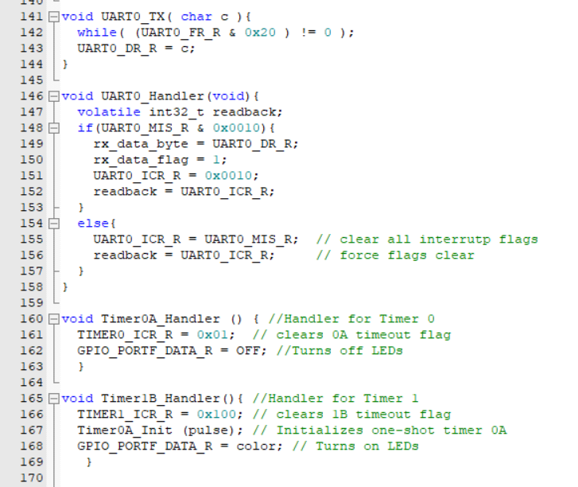

**Conclusion:**

In conclusion, this lab allowed us to restrengthen our knowledge on using the UART and combined the functionality of the previous lab to create an engaging experience. The UART allowed us to communicate and simulate the change of led color and brightness based on the input on the computer. We did encounter an error where the UART menu would only display half of the welcome string. After troubleshooting the code, we resolved this issue after realizing that we had mislabeled a variable. It took awhile to resolve this error because there were no syntax error in the code so we had to thoroughly look at each line of the code. Overall, this lab strengthened our knowledge of UART and will give us a good transition moving into the next lab.